METABOLISM MASTERCLASS
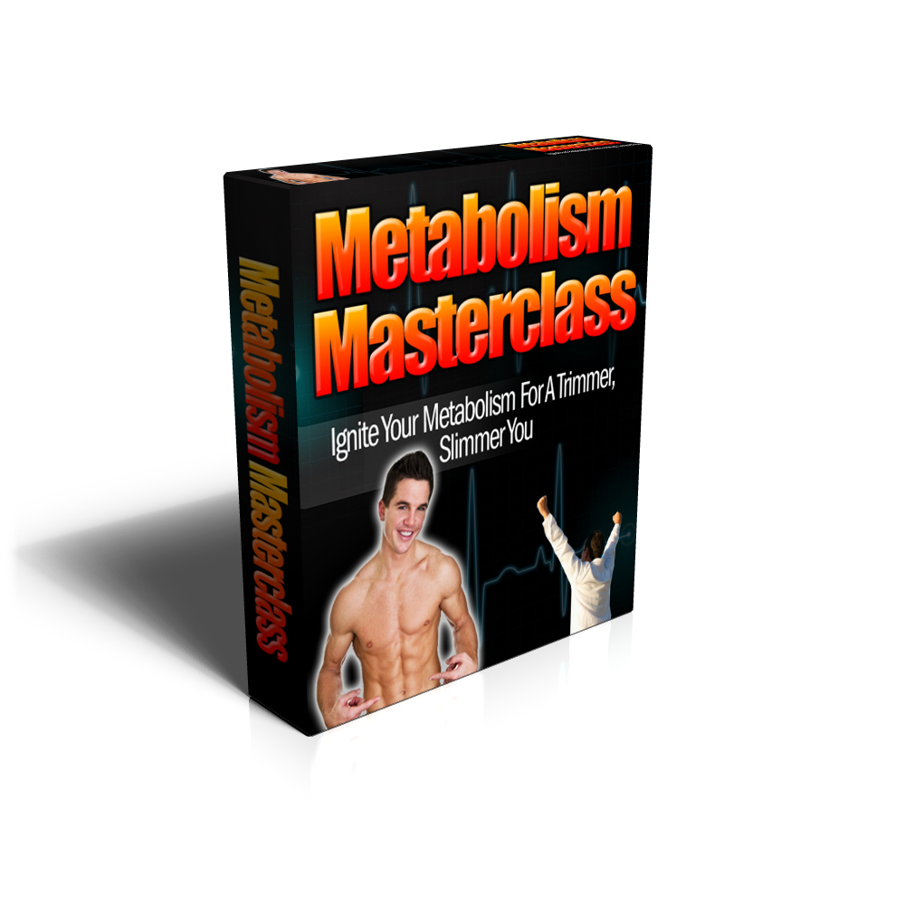
FIRE UP YOUR METABOLISM AND ACHIEVE LASTING AND NATURAL WEIGHTLOSS STARTING TODAY!

Welcome!

Thanks for joining us inside this exclusive free report looking at the importance of boosting our metabolisms to the highest possible level in order to achieve the sexy body and healthy future we all hope for!

Often, people feel like they’re just “stuck” with the metabolism Mother Nature gave them. If they feel sluggish and tired a lot of the time, have a tendency to put on weight and lose muscle tone, they put it down to unlucky genes and either give up and get extremely unhealthy or spend all their time looking for some ‘miracle fix’.

This is a huge mistake, and very common misconception! The only “miracle” you need to be aware of is the miracle of your very own body, which is so fluid and receptive that anyone, and I mean ANYONE, can boost their metabolism quickly and easily and enjoy rapid weightloss and increased energy as a consequence!

Today, let’s begin to talk about how we can achieve just that!

If you have heard about metabolism, chances are it is in relation to weight loss. Metabolism is bigger than weight loss, though, as you will learn later on. It is about a healthier, better you.

If you want to fire up your metabolism and do not have any idea how to do it, you have come to the right place. If you have tried to speed up your metabolism before but do not see visible results, you have also come to the right place.

Before we go any further, let’s master the basics… What exactly is one’s metabolism?

Well, metabolism, in its most basic sense, is the body’s conversion of the calories from the food you eat into energy. It is a series of chemical reactions that give your body the energy to do what it needs to do to keep functioning – and consequently, for you to keep living. Without metabolism, you would not be able to move or think. Metabolism provides energy for your body and your individual organs to work smoothly.

To better understand the importance of metabolism, consider this: if your heart stops beating, you die. Likewise, if your metabolism stops, you die – because without metabolism, you will not have the energy even to breathe, or for your heart to beat!

Here’s How It All Works…

First, let us start with the act of eating. As you chew and swallow your food, it goes down to your digestive tract. Digestive enzymes then break down your food – carbohydrates to glucose, fats into fatty acids, and protein into amino acids. After the nutrients are effectively broken down, they are absorbed by the bloodstream and are carried over to the cells. Other enzymes plus hormones then work to either convert these nutrients into cells or building blocks for tissues or release them as an energy supply for the body’s immediate use.

Metabolism Types and Components

There are two basic metabolic processes – one is constructive, and is responsible for building and storing energy for the body. The other is destructive, though in a positive sense, as it breaks down nutrient molecules to release energy.

The constructive metabolic process is called anabolism, while the destructive process is called catabolism.

Anabolism promotes the growth of new cells, the maintenance and repair of tissues, and the storage of energy – usually through body fat – for future use. Small nutrient molecules are converted into larger molecules of protein, carbohydrates and fat.

Catabolism, meanwhile, is responsible for immediately providing the body energy to use. Instead of building up, it breaks down the nutrient molecules to release energy.

These two processes do not occur simultaneously but are balanced by the body.

Catabolism, in particular – though some attribute this to overall metabolism – has three components:

- Basal metabolism → Sometimes called resting metabolism, this is the metabolism component responsible for keeping you alive by ensuring normal body functions. Even if you were bedridden the whole day, basal metabolism is still at work.

Basal metabolism is metabolism’s main component, as 60 to 70 percent of the calories from the food you eat are used for this. People who want to lose weight usually aim for a higher basal metabolic rate (BMR).

- Physical movement → This can range from a simple moving of your fingers to strenuous exercise. Usually 25 percent of the calories you consume go here.

- Thermic effect of food → This indicates the digestion and processing of the food you take in. Normally, ten percent of the calories of the food you eat are burned through this.

Thus, taking all this into account, here is our metabolism formula:

Calories From Food = Calories Expended From Basal Metabolism (60-70%) + Calories Expended By Physical Movement (25%) + Calories Expended Digesting Food (10%)

What Affects Metabolism?

Your metabolic rate, or how fast or slow your metabolism works, is influenced by a number of factors:

- Genetics → Yes, metabolic rate is also inherited. Sometimes this makes an entire world of difference between a person who can eat almost everything and not gain an ounce and a person who easily balloons after indulging just once.

- Age → The younger you are, the faster your metabolism is. Metabolism slows down as you age. Women’s metabolic rate starts falling at the age of 30; for men, decline starts later at the age of 40.

- Gender → Men have a faster metabolic rate – usually 10-15 percent faster – than women because their bodies have a larger muscle mass. Muscle plays a key role in fast metabolism, as will be discussed in the chapter on exercise.

- Amount of lean body mass → As already mentioned above, more muscle = faster metabolism.

- Diet → Some foods will help you, some will only harm you. While timing is not everything, when you eat also greatly affects your metabolism. The difference is discussed in the chapter on eating right.

- Stress level → Stress is inversely proportional to metabolism. The more stress you are subjected to, the lower your metabolism. You will better understand this when we move on to the chapter about stress.

- Hormones → Specific hormones metabolize specific nutrients. How well the hormones work, then, directly affects metabolism. To a certain extent, diet and stress levels affect the hormones involved in metabolism, as you will find out later. Hormonal disorders or imbalances can affect metabolism as well.

Looking at all these factors that influence metabolism, you now probably have a general idea of what you need to do to increase your metabolism – accept the things you cannot change, and work on those that you can!
But before we get into the detailed program for firing up your metabolism, first, know what’s in it for you! And find out the kind of resolve you need to achieve the level of metabolism you want.

So Why Should I Bother Trying To Fire Up My Metabolism? What’s In It For Me?

Well, it’s not all about weight loss, though discussions on metabolism seem to focus almost exclusively on this concept. In fact, even if you feel that your weight is perfectly fine, you have a lot to gain by increasing your metabolism. Following a list of the benefits you stand to gain by applying the advice in this book:

- Lose weight. Let’s start with the most obvious benefit. By increasing your metabolism, particularly your BMR, you will burn more calories just by doing the activities you usually do. Even while you lie in bed and stare at the ceiling or even while you are sleeping, your body is working to burn the calories you consume. With an increase in metabolism, you can actually shed one or two pounds a week. Best of all, the results are long-term, unlike a quick-fix diet! Now, isn’t that more satisfying – and easier – than going on a fad diet?

- Eat more without worrying about it. Since you burn calories faster now, you can eat more without feeling guilty. This does not mean overindulging or snacking on junk food, though. But in general, you can be less concerned about the quantity of food you eat.

- Feel more energized. People with faster metabolism report having more energy. With a faster metabolism, your body is performing efficiently to release the energy you need to get going.

- Look better. The skin of people with a fast metabolism is brighter and more radiant. Their faces are pinkish, more alive with color. With a faster metabolism, you will not only feel good but also look good!

- Be healthier overall. Your body functions more efficiently with a faster metabolism. Digestion, absorption of nutrients and blood circulation are improved. And you won’t need as much sleep as you did before to feel refreshed the next day.

In sum, expect a faster metabolism to make you look and feel more wonderful!

Well, for now this concludes our jump into all things related to boosting your metabolism and all the many benefits that brings! I hope you enjoyed this, and I know I really enjoyed conveying all this information and insights to you. Now I’m sure this has just left you with a taste for more, and the great news is that we have lots more detail just waiting for you!

We want to really uncover all the secrets and tips in the area of metabolic maximization and fat loss for you, and so we’ve created and compiled the most comprehensive manual that you will ever read! We worked with all the top experts in the field to bring all this incredible content together, and believe me, this is information that will have a real impact on your life! So if you’re keen to grab your copy of our totally tell-all, ground-breaking book on mega-charging your metabolism, then you simply must head here now:

Hurry, as copies are selling fast and we’d just hate for you to miss out! I know you don’t want to be disappointed or left out, and instead want to discover all you can about boosting your metabolism, so you too can lose excess weight and gain energy and vitality! So click on the link above, and secure your copy today!

Thanks again for joining me in this up-to-the-moment discussion about your metabolism, and enjoy your comprehensive manual that you can obtain and start reading today!

Yours in health and vitality,

